29.51: From Example 29.4, 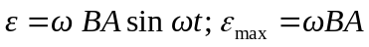
For  loops, 